The Infinite Campus Parent Portal is a web-based student information system that provides instant and real-time information to those users with an internet connection who have students in our schools. Additionally, Infinite Campus is a family-based system, which means parents/guardians can easily use their own log-in to view information for all their students. The portal offers current information on grades & assignments, report card, attendance, schedules, and school & district announcements.

Account Activation Instructions.
1. The first time you use the Campus Portal, you will need to set up your account.
2. Open the browser of your choice and go to this web page: https://wicloud3.infinitecampus.org/campus/portal/parents/aoe.jsp
3. You will see a login screen. For new users, click “NEW USER?”
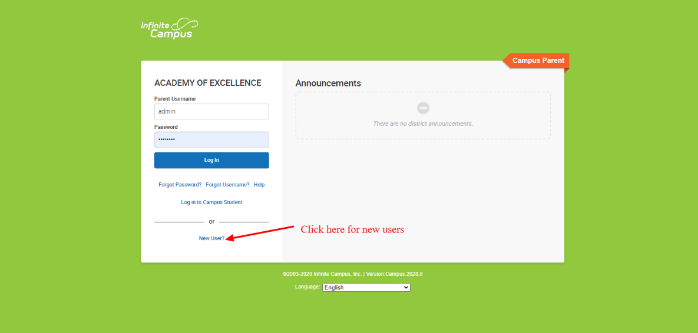
4. You will see the “Activating your Campus Portal Account” screen.
5. Type your 32-digit Activation Key into the Activation key field. Do not enter the dashes. When you have entered all 32 digits/letters correctly,
click on submit.
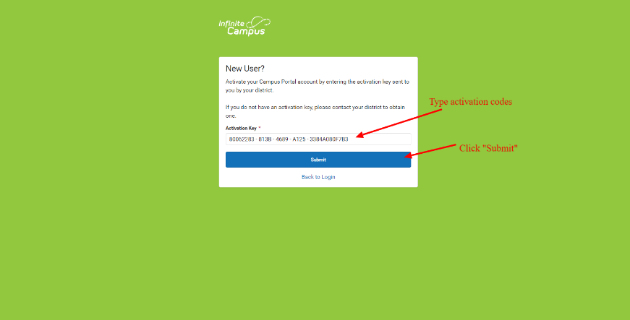
6. You will see your personal account creation screen. The “Welcome” line at the top should list your name. If it does not, stop and submit the tickets at https://academyofexcellence.freshdesk.com/ (Note: If you already have parents account, please click “forgot username” Or Submit tickets):
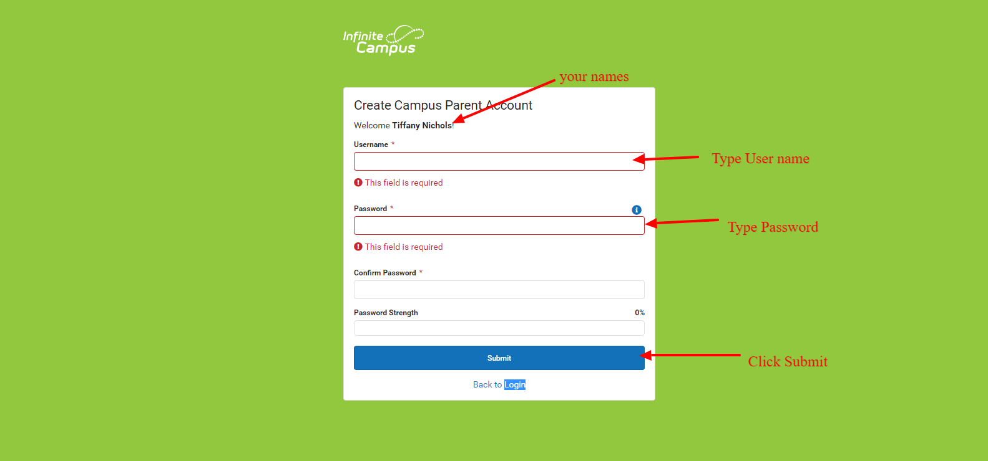
7. On this screen you will enter a user name and password that will subsequently permit you to sign in and look at your child’s information. The program has you enter the password twice to ensure accuracy. The percentage box will let you know if your password is secure enough. Keep your password confidential. Security of students’ personal and private data is of paramount importance to the Academy of Excellence.
8. Once you have entered your user name and password information in the fields, click on Create Account. Campus will congratulate you! Your account is set up and you can subsequently sign on using the User Name and Password you entered. You will then be prompted thru security preferences.

To request the activation codes or issues with registration, please submit the tickets at https://academyofexcellence.freshdesk.com/

For google classrooms, infinite campus parents/students portal tutorials, please go to https://academyofexcellence.freshdesk.com/

